Database Project Queries
Submitted By: Omar Nadeem Siddique – L1F21BSCS0427
Submitted To: Sir Usama Pervaiz
Section: D-13
2023
Queries that makes all the tables in the database:
Making a database with the name of Judiciary
Queries
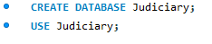
Result
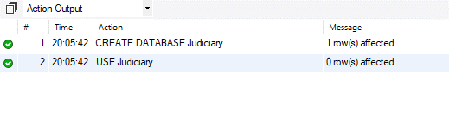

Making all the necessary tables
Queries
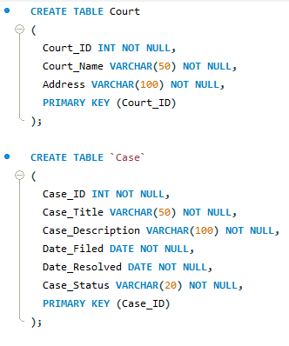
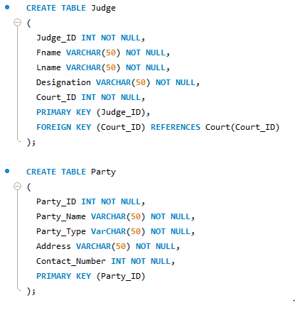
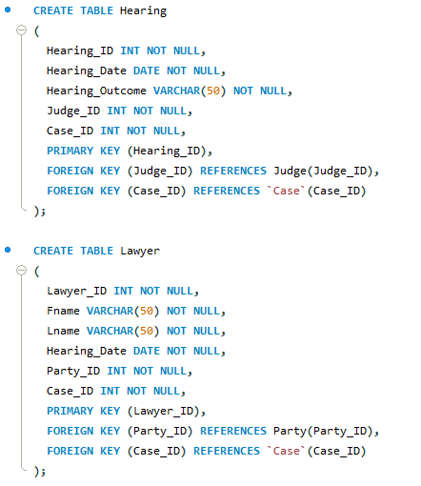

Result
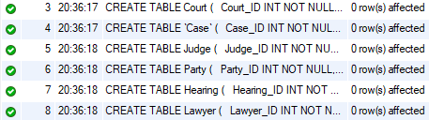

Inserting the data
Queries
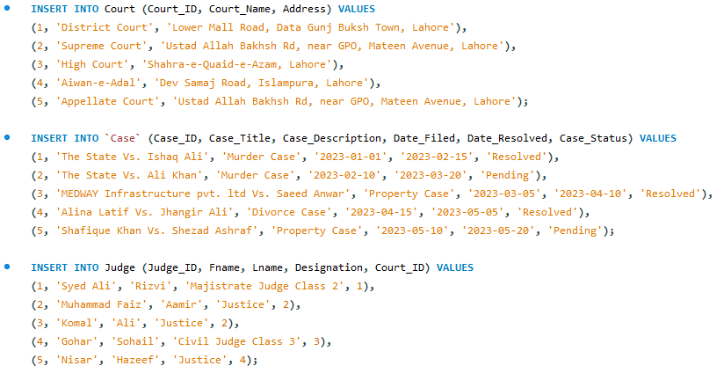
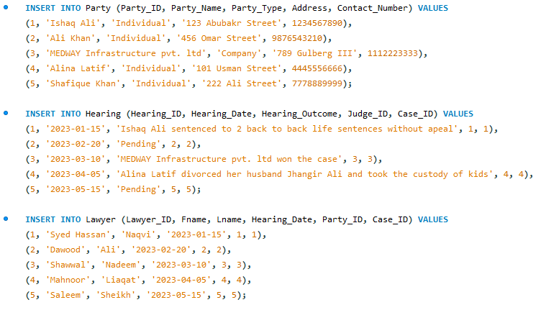
Result
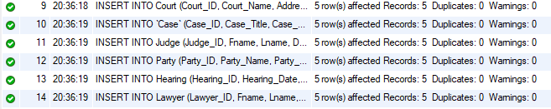

Remove Data
Queries
Result

Update already existing data
Queries
Result

